🚀 AI Co-Founder: "Startup Genie" – Complete Development Plan
An AI-powered startup brainstorming, pitching, and execution assistant that helps small startups refine ideas, generate business plans, create investor pitches, and automate outreach.

📝 Project Breakdown

🔹 Features & Capabilities
- AI Idea Validator – Helps refine startup ideas based on market trends, feasibility, and competition analysis.
- Business Model Generator – Creates a Lean Canvas or a structured business model.
- Investor Pitch Creator – Generates customized pitch decks for investors (VCs, angels, accelerators).
- Cold Outreach Automation – AI writes and automates outreach emails/messages for investors and potential customers.
- Early MVP Prototyping – AI assists in generating simple landing pages, product descriptions, and business logic.
- Competitor & Market Research – AI scrapes and analyzes market data, trends, and funding rounds.
- Execution Assistant – AI generates initial tasks, milestones, and basic workflows for early-stage startups.

📅 Timeline (8-Week Plan)

🟢 Phase 1: Research & Planning (Week 1)
✅ Define MVP scope: What’s essential vs. what’s a later add-on?
✅ Research existing solutions, APIs, and open-source tools.
✅ Plan UI/UX design and backend infrastructure.
✅ Choose tech stack:
- Frontend: React/Next.js (Vercel free tier)
- Backend: FastAPI/Flask (or Firebase for low-cost hosting)
- Database: PostgreSQL (Supabase free tier)
- AI Models: Open-source LLMs (Mistral/Mixtral), vector embeddings (FAISS)
- Scraping: BeautifulSoup/Selenium/Playwright for competitor analysis
- No-Code Integrations: Webflow/Bubble for MVP generation
📌 Deliverables:
- Clear architecture diagram
- Feature list + priority roadmap
- Wireframes for main UI

🔵 Phase 2: Core AI Development (Weeks 2-3)
🔹 AI Idea Validator
- Fine-tune LLM to analyze startup ideas
- Integrate with trend databases (Crunchbase alternatives, Google Trends API)
- Provide instant feedback (e.g., market saturation, feasibility)
🔹 Business Model Generator
- Implement structured business model templates (Lean Canvas, SWOT analysis)
- AI fills out key details based on user input and market research
📌 Deliverables:
- Working AI models for idea validation and business model generation
- Simple API endpoints for AI interactions

🟣 Phase 3: UI Development & Integration (Weeks 4-5)
🔹 Frontend Development
- React/Next.js for smooth, interactive UX
- Drag-and-drop functionality for startup customization
🔹 Backend Integration
- API endpoints for AI responses
- Job queue for asynchronous tasks (Celery/RabbitMQ for handling scraping)
🔹 Market & Competitor Research Module
- Implement scraping for competitor/funding research
- Data storage (PostgreSQL/Supabase)
📌 Deliverables:
- Functional frontend with basic AI interactions
- Competitor research scraping working in the background

🟡 Phase 4: Investor Pitch & Outreach Automation (Weeks 6-7)
🔹 Pitch Deck Generator
- AI creates structured pitch decks (slides with financial projections, business vision, market analysis)
- Export as PDF/PPT
🔹 Cold Outreach Automation
- AI crafts investor emails with personalization
- Integration with Gmail API / LinkedIn API for sending outreach messages
📌 Deliverables:
- AI-generated pitch decks
- Outreach automation system working (test with a few dummy emails)

🟠 Phase 5: Testing, Deployment & Marketing (Week 8)
🔹 Testing & Optimization
- Debug AI responses, improve market analysis accuracy
- User testing with early-stage startup founders
🔹 Deployment
- Host on Vercel (frontend), Railway/Supabase (backend & database)
- Optimize LLM usage (self-host Mixtral or use OpenAI API for some features)
🔹 Marketing & Growth Strategy
- Launch on Product Hunt, IndieHackers, LinkedIn
- Offer free beta access to 100 startups
- Build case studies from early users
📌 Final Deliverables:
✅ Fully functional AI co-founder tool
✅ Public beta launch 🚀

🛠 Tech Stack Summary
Component | Tech Stack Used
Frontend | React / Next.js (Vercel)
Backend | FastAPI / Flask (Railway)
Database | PostgreSQL (Supabase)
AI Models | Open-source LLMs (Mistral, Mixtral, GPT-3.5 for fallback)
Scraping | Playwright / Selenium
Automation | Celery (for async job handling)
Market Research API | Google Trends API, Alternative APIs for Crunchbase

💰 Cost & Budget (💸 $0 Development Plan)
Resource | Free Tier Used
Hosting | Vercel (Frontend), Railway/Supabase (Backend)
Database | Supabase (PostgreSQL Free Tier)
AI Models | Local LLMs (Mistral, Mixtral) or OpenAI free tier
Scraping | Playwright/Selenium on free-tier cloud compute
Emails | Gmail API (Free usage limits)
MVP No-Code | Webflow (Free tier)

🔮 Future Expansions
🚀 Freemium Monetization Plan
- Basic Users (Free): Limited AI features, 5 idea validations/month.
- Pro Users ($9.99/mo): Unlimited validations, full investor outreach automation.
- Startup Accelerator Mode ($99/mo): VC firms access AI-screened startup recommendations.
🚀 Advanced Features (Next Iteration)
- AI-powered financial projection analysis
- Personalized mentorship (AI suggests startup mentors based on industry)
- Automated customer persona generation

👀 Why This Will Succeed?
🔥 No One Has Built This Yet – AI co-founder concept is untapped
🔥 Small Startups NEED This – Solo founders struggle with execution
🔥 Freemium Model Works – Startups will pay for better investor outreach & business planning

Product Overview
AI Startup Assistant is a free AI-powered tool for early-stage startups that helps validate business ideas, generate structured business models, and create investor pitch decks. Unlike traditional consulting or generic AI chatbots, this tool offers a structured end-to-end ideation workflow designed specifically for startup founders.

Target Users
- Early-stage founders looking for structured AI feedback.
- Startup incubators needing an automated validation tool.
- Freelancers & consultants who assist in business planning.
- Investors & accelerators looking for quick idea insights.

Roadmap & Next Steps

Phase 1: Planning & Research (Week 1) ✅
✔ Define MVP features & scope.
✔ Competitor research & gap analysis.
✔ Wireframing & API architecture design.

Phase 2: Core AI Development (Week 2-3)
🚀 Set up FastAPI backend.
🚀 Implement Idea Validator AI with FAISS & LLM.
🚀 Develop Business Model Generator.

Phase 3: UI & Final Integration (Week 4-5)
💻 Build React frontend UI.
📊 Implement Pitch Deck Creator AI.
🎯 Launch MVP for early testers (startups & incubators).

Phase 1: Research & Planning (Week 1):

Step 1: Define the MVP Scope
To keep things simple and focus on the core value, let’s define the absolute essentials that we need for the first working version.

MVP Features (Must-Have)
- AI Idea Validator – Analyzes startup ideas and gives feedback based on market trends.
- Business Model Generator – Creates a simple business model (Lean Canvas format).
- Investor Pitch Creator – AI auto-generates a pitch deck based on the business model.
What we are NOT including (yet! )
- Automated cold email outreach (future phase)
- Market research scraping (will add in Phase 3)
- MVP landing page builder (for later expansion)

Core Features & Functionalities

📌 Feature 1: AI-Powered Idea Validator
💡 What It Does:
- Analyzes startup ideas based on existing market data, competitor landscape, and feasibility.
- Predicts strengths, weaknesses, and risks.
- Suggests potential pivots or modifications.
📥 Inputs:
- Startup idea (short description).
- Industry category.
📤 Outputs:
- AI-generated validation score (0-100) based on feasibility.
- Strengths & Weaknesses Analysis (text).
- Suggested Modifications (alternative approaches).

📌 Feature 2: AI Business Model Generator
💡 What It Does:
- Automatically generates a Lean Canvas or Business Model Canvas based on the idea.
- Suggests revenue streams, key partners, cost structure, etc.
- Provides monetization strategies based on industry trends.
📥 Inputs:
- Startup idea.
- Target market.
- Business goal.
📤 Outputs:
- Business Model Canvas (text + structured format).
- Recommended revenue strategies based on industry benchmarks.
- Potential growth challenges & mitigation strategies.

📌 Feature 3: AI-Generated Investor Pitch Deck
💡 What It Does:
- Creates a 10-slide investor pitch deck with key startup information.
- Auto-generates key points, graphs, and financial projections.
- Exports in PDF / PowerPoint format.
📥 Inputs:
- Startup idea.
- Business model details (from previous step).
📤 Outputs:
- AI-generated Pitch Deck (PPT/PDF).
- Market validation graphs (AI-generated visuals).
- Competitor differentiation slides.
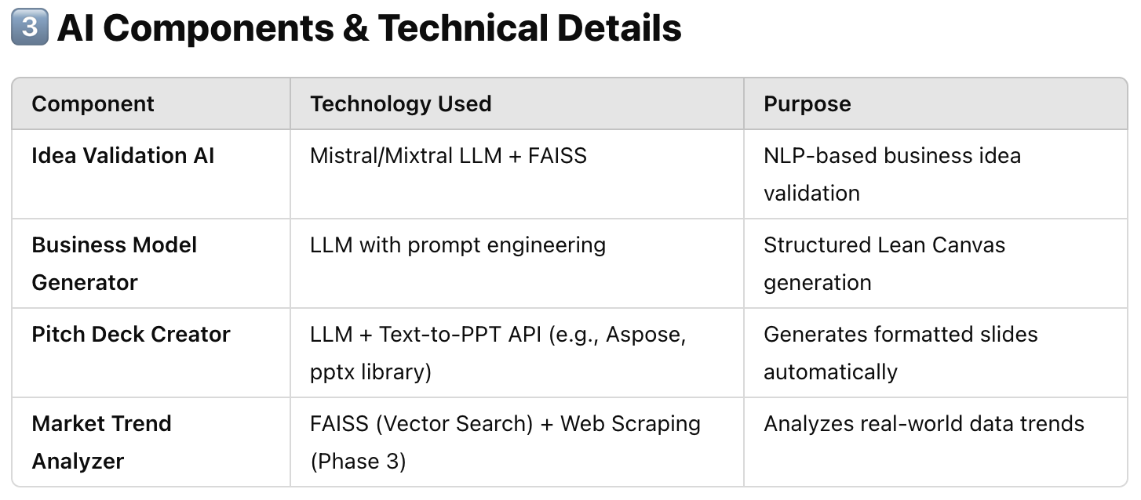

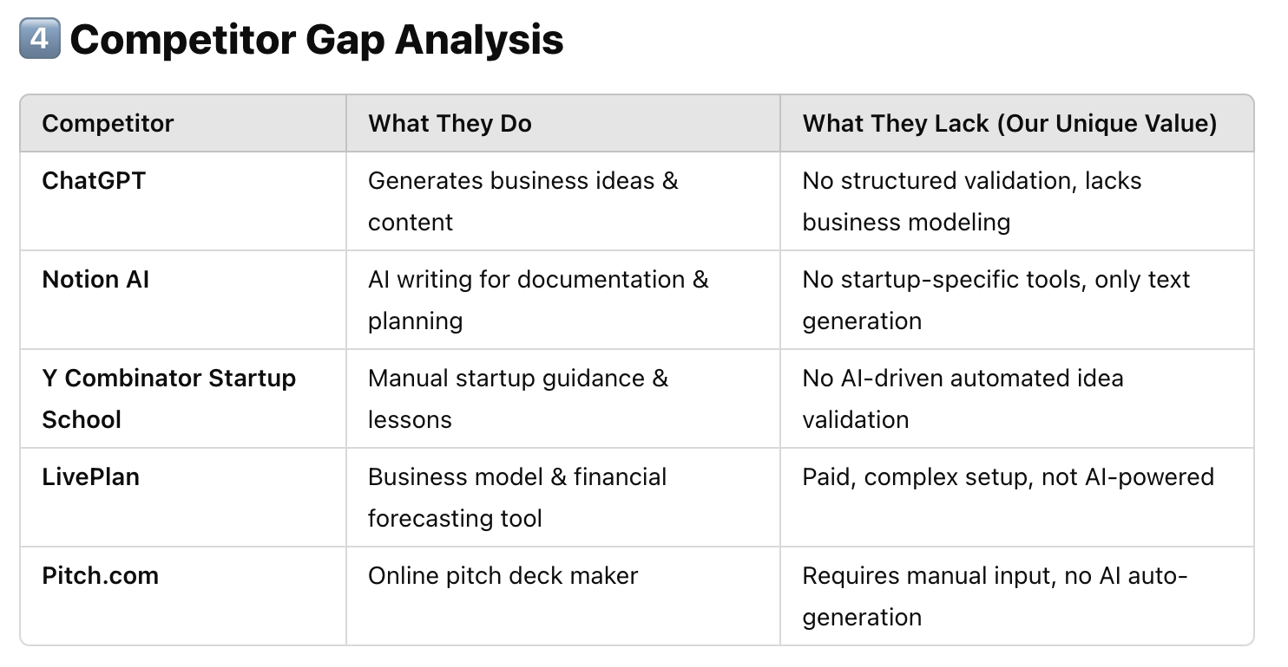

Architecture Overview
The system consists of:
- Frontend (React + Vercel) – User enters startup idea and receives feedback.
- Backend (FastAPI + Railway) – Handles AI processing and API requests.
- AI Models (Mistral/Mixtral + FAISS) – Generates idea validation, business models, and pitch decks.
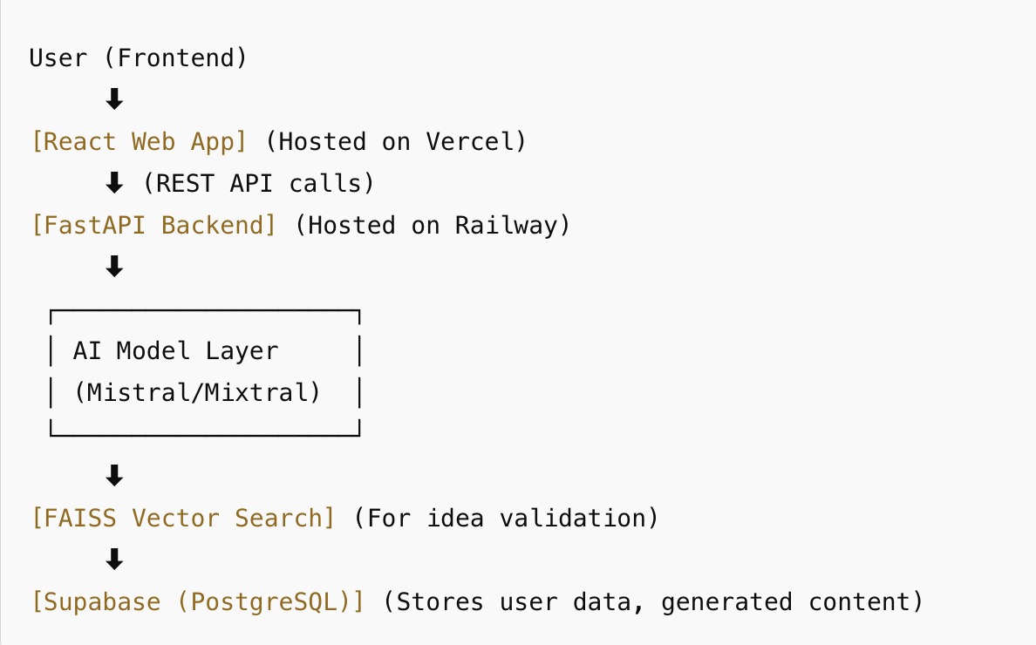
- Database (Supabase/PostgreSQL) – Stores user input, feedback, and generated content.

